P value – Many People gest’s confused

What is P value – Lets start by one example.

In the mousepad,

Distribution of touches. Example P=0.8

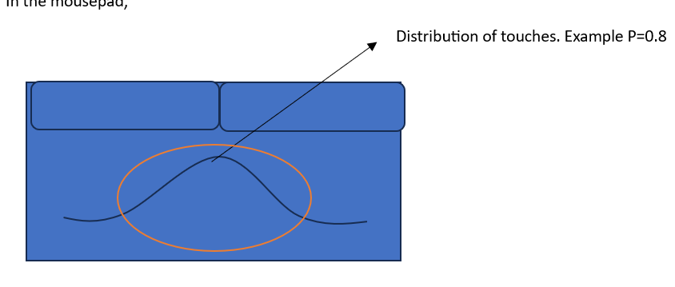

Most of the time when we use touch pad most of you touches inside red circle, If one says that P- Value for touches is 0.8, Means out of 100, 80 touches on that point or 100 times if one touch the mouse pad, 80 times that he touches he specifically,

Same way if one says P Value at left corner is 0.01, which means out of 100 touch one 1 time at that point.

P=0.01 (1 times)

## With this P value we will study combine study of

Hypothesis testing

Confidence Interval,

Significance Value

Problem -Test whether this coin is a fair coin or not by performing 100 tosses.

Inferential statistics

Fair Coin properties, Conditions.

when P(H) =0.5; P(T)= 0.5

If you have Shole Movie Coin Probability will be P(H) = 100 %; P(T) = 0.

In Fair Coin If I toss 100 times. Head 50 Times and Tail 50 Times than I can say coin is fair.

In this scenario. Let’s study, Hypothesis Testing.

1 Null Hypothesis – The Null Hypothesis is usually given in the problem statement. In above example the coin is fair or not.

The default is Coin is fair – Null Hypothesis.

Same way a person, a person cannot be acquitted as criminal unless and until it is proved.

2 Alternate Hypothesis - Coin is Unfair. Opposite of Null Hypothesis.

3 Experiment – Can be any test like Z test, T test.

4 Reject or Accept the Null Hypothesis

Let’s see this by example, For the fair coin mean should be 50 times head. Distribution will be like below. If I know the mean and standard deviation.

10 20 30 40 50 60 70 90

mean

What happen if I want to prove this? I will perform the experiment. Toss 100 times.

Imagin, you got 30 times head. Which means 30 in the Distribution. In this case

can we still say this coin is fair?

Can we say this coin is unfair?

For this to define, it is always said that our experiment should be nearer to the mean.

Nearer to mean is fairer.

Away from the mean is near to unfair.

Now how do we define that how far it can be away from the mean we need to define that how far it may be away from the mean. For that we use a very important property. Which is called as significance value is basically given by alpha suppose let’s consider that I am considering alpha as zero five.

Alpha = 0.5, or 5 % what exactly this means. This is defined by domain expert.

It means if I subtract 100 – 5 = 95 this basically indicate that 95 % confidence interval.

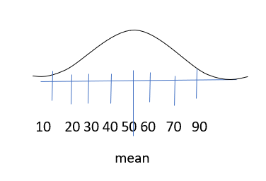

2.5% 95% 2.5 %

Whenever we are coming inside red line (95 %) the coin is fair.

If it falls outside this confidence interval or red line. That mean the coin is not fair.

If you see not 20 and 75 is my confidence interval.

Another example

If get only 10 heads of 100 experiment. Should we accept or reject the null hypothesis?

It means 10 heads mean.

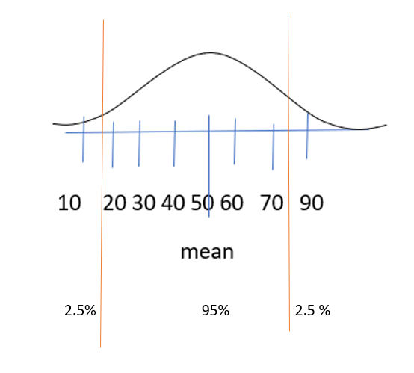

10 heads mean in this point. This means out from confidence interval.

We reject the null hypothesis. Which means coin is not fair. 95

Another example, if get 95 heads which means it falls in between 100 and 95. Which is outside of confidence interval. So, should we accept the null hypothesis or reject?

In this case also, Null Hypothesis is rejected which means coin unfair.

If alpha is 0.20 which means 20%

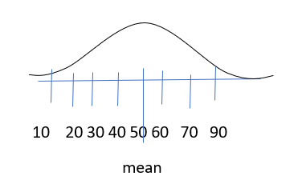

0-10 80% 0-10

IF signific level is 0.3 means. The confidential level is 70 %

